The Clock

MATERIAL:
Clock (can be handmade)
Clock hands should be two different colors
Labels that say “midday” and “midnight” and “AM” and “PM”
Here’s a free tutorial to make a handmade clock.

IMPORTANT: These lessons can be given over a period of several months as the child gains awareness and practices reading the clock. Some children will pick this up in a matter of weeks; others can take up to a year to understand all the concepts. Both are acceptable and normal.

INTRODUCTION:
- In our day, we have daytime and nighttime. We say that there are 12 hours of day and 12 hours of night.
- Put the hands on 12 o'clock. Show how the hands spin clockwise.
- There are 24 hours in a day: this is twice around the circumference.
- We have two hands: one short and one longer. The short hand moves slowly because it takes one hour to pass from 12 to 1. It moves from arc to arc. Each arc is 1 hour, so there are 12 hours all around the clock. Each of the divisions is called an hour.
- The long hand moves more quickly. We can see small marks between each number. If we count them all the way around we would find that there are 60 of them. They are called minutes. The long hand indicates the minutes; there are 60 minutes in one hour. Minutes comes from the Latin word minutus, meaning small.
- Count the divisions with the children: how many are there between 12 and 1? Between 1 and 2? The divisions are grouped by 5, which means we can skip count by 5. We can also use multiplication: 5 taken 1 time is 5; 5 taken 2 times is 10; 5 taken 3 times is 15...
- Show a real clock. The thin hand moves more quickly through the 60 divisions. It counts the seconds. That comes from Latin secundus, meaning following.
- Ask the children to close their eyes. Tell them that when they think a minute has elapsed, they can raise your hand. They can also tap out a minute.

Reading and Telling Time:

PRESENTATION A: O’clocks
- Our reference point can be midday.
- Put both of the hands of the clock on 12. Tell them it's midday and put out a label.
- Explain: We call this 12 o’clock.
- Move the minute hand one time around and the hour hand to 1 o'clock. Explain: Because it's after midday, it's postmeridian, meaning it's P.M. Put out the label saying "PM". Continue moving the hour hand and explaining: this is 2 o'clock, this is 3 o'clock, etc.
- You will reach midnight. Change the label to midnight. Go to 1 o'clock AM. Change the label to read "AM". Keep going until you reach midday again.

PRESENTATION B: Half-pasts
- Start at 12 o’clock.
- Move the minute hand down to the 6.
- Explain: We’ve gone halfway around the clock.
- Use the ‘half’ fraction insert to show on the face of the clock that you’ve gone halfway around.
- Explain: this is half-past 12.
- Next, make 1 o’clock or ask the child to make it.
- Then, show how to make half-past one.
- Make 2 o’clock and invite the child to make half-past two. Continue making o’clocks and half-pasts with the child, asking them to verbalize the times.

PRESENTATION C: Quarter past
- Start at 12 o’clock.
- Move the minute hand down to the 3.
- Explain: We’ve gone one fourth of the way around the clock.
- Use the “fourth” fraction insert to show on the face of the clock that you’ve gone one fourth of the way around.
- Explain: Another way of saying “one fourth” is “one quarter.” We’ve gone one quarter of the way around; we went one quarter of the way past twelve.
- Explain: this is quarter-past 12.
- Next, make 1 o’clock or ask the child to make it.
- Then, show how to make quarter-past one.
- Make 2 o’clock and invite the child to make quarter-past two. Continue making o’clocks and quarter-pasts with the child, asking them to verbalize the times.

PRESENTATION D: Quarter to
- Start at 12 o’clock.
- Move the minute hand around to the 9.
- Explain: We’ve gone three fourths of the way around the clock.
- Use the “fourth” fraction insert to show on the face of the clock that you’ve gone three fourths of the way around.
  - Place the fraction inset in the space between 12 and 3 and say: this is one quarter. Then flip the fraction piece so it shows the quarter between 3 and 6, and say: this is another quarter. Then flip the fraction piece so it’s in the space between 6 and 9 and say: This is another quarter.
- Ask: How many quarters are left until we get to the next o’clock? The child will say “one.”
- Explain: We call this position “quarter to or quarter til. It is quarter to one, because there’s only one quarter left until the clock gets to one o’clock.
- Next, make 1 o’clock.
- Then, show how to make quarter-to two.
- Make 2 o’clock and invite the child to make quarter-to three. Continue making o’clocks and quarter-to’s with the child, asking them to verbalize the times.

PRESENTATION E: Telling time to the five-minute mark
- Ask: Do you remember there were 5 little marks or divisions between 12 and 1?
- Start at 12 o'clock and move the minute hand 5 minutes. Now we have "5 minutes past 12".
- Move the minute hand 5 more minutes. Explain: We have 5 + 5 = 10. It's "10 past 12".
- Move the hand 5 more minutes. Explain: We skip count: 5, 10, 15. We can say "15 past 12", or "quarter past 12".
- Keep going in this way.

Telling Time to the One-Minute Mark:

- Most children will figure this out on their own.
- Introduce reading the clock to the minute only if the child doesn’t figure it out themselves.

Elapsed Time

Materials:
- Task cards
- Manipulable clock

PRESENTATION: Elapsed Time
- Explain: The clock doesn’t just tell us what time it is. It can help us figure out how much time is left in an activity, or how much time we have left until we need to go somewhere.
- When I say: “We left our house 20 minutes ago,” that means that 20 minutes have passed or “elapsed” since we left our house.
- If I say “It’s 2 o’clock and the party starts at 2:30,” then the elapsed time is 30 minutes.
- We can check that on our clock:
  - Make 2 o’clock as the start time
  - Ask your child to make 2:30
  - Ask them to show you how many minutes the minute hand went through to get to 2:30
  - Point out that that’s the elapsed time
- Give a few more EASY verbal examples:
  - The race started at 10am. John crossed the finish line at 10:45am. How much time elapsed between the start of the race and when he finished?
  - I put the cake in the oven at 5pm. It takes 45 minutes to bake. At what time do I need to take it out?
- Introduce these task cards and explore them together, starting with the easier ones.

FOLLOW-UP ACTIVITY: My day

MATERIALS:
- The children use a clock stamp or clock printable to chronicle their day.
  - Clock stamp can be purchased here.
  - Clock printable can be downloaded free here. (scroll to “My Day” clock booklet)

ACTIVITY:
- Help your child to make a blank booklet or timeline to chronicle their day.
- Help them write on each page one thing they do during the day (e.g. wake up, brush teeth, eat breakfast, etc.)
- The child can draw the minute and hour hands on the clock to correspond with the time of day when they do each activity (optional: they can write the time with numbers too).
- They can also draw a picture of what they’re doing at that time.
- Emphasize AM and PM (see introductory lesson above for the instructions).
- Cut the booklet pages and show your child how to glue back to front.

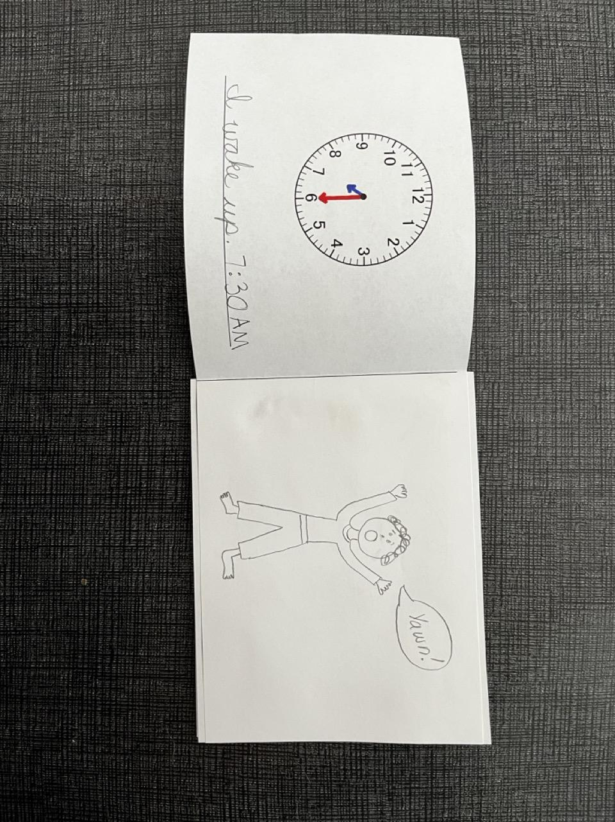

Extension: Timetables and uses of time
- Introduce timetables and different uses of time (time tables, train schedules, sand clocks, sun dials, etc.)

